|  |
| --- |
| DAMAN for SME’s |
| **DAMAN for SME’s** |
| **Political Risk Insurance Scheme Proposal for direct support** |
|  |
| **New Vision Consultancy** |
| **1/1/2017** |

|  |  |  |  |  |
| --- | --- | --- | --- | --- |
| **C:\Users\Smart\Desktop\ضمان-01 (4).jpg** | Description: newvision | ASALA LOGO.jpg | ACAD.jpg | sidi.bmp |

|  |
| --- |
| *DAMAN for SME’s is a financial compensation tool for vulnerable persons and groups such as women, youth, small and micro entrepreneurs directly affected by policies imposed by the illegal occupation in the Palestinian Territories.* |

**DAMAN for SME’s**

Political Risk Insurance Scheme

Proposal for direct support

1 –Overview& Background 3

Existing Scheme 3

2. Context: Long-lasting Impact of Illegal Occupation in Palestine 4

West Bank 4

East Jerusalem 5

The Gaza Strip 5

3. Rationale of the scheme 5

Summary of Activities 6

ACAD 6

ASALA 7

4. Description of the DAMAN Activities 7

5.Funding 8

Annexes 9

Annex 1 - Means of verification for the claims 9

Annex 2 - Stories of clients after ‘Operation Protective Edge’ 11

ACAD Borrower 11

ASALA Borrowers 13

# 1 –Overview& Background

**DAMAN for SME’s** is a non-profit company for the Credit Guarantee Scheme registered in Ramallah in the Palestinian Territories under the Palestinian law.

**DAMAN for SME’s** is a non-profit company for the **Credit Guarantee Scheme**. It is a partnership between the Arab Center for Agricultural Development (ACAD), the Palestinian Business women’s Association (ASALA), International Solidarity for Development and Investment (SIDI)- France. New Vision Consultancy acts as the management wing for the company.

DAMAN for SME’s is a financial compensation tool for vulnerable persons and groups such as women, youth, small and micro entrepreneurs directly affected by policies imposed by the illegal occupation. DAMAN will focus on those residing in areas affected by the separation wall in the West Bank, East Jerusalem and Gaza. DAMAN for SME’s will maintain the political risk scheme initiated in 2008, and expand it to encompass occurrences of damages endured by borrowers as a result of the Israeli occupation of the Palestinian territories, expanding its outreach in West Bank , Gaza Strip and to also include coverage to those entrepreneurs residing in East Jerusalem.

## Existing Scheme

The **Credit Guarantee Scheme** was designed in 2008 to strictly cover political risk which encountered ASALA & ACAD clients (borrowers) in the West Bank and Gaza. New Vision has been selected by the three partners to act as the Palestinian Credit Guarantee Scheme Management Centre to monitor and verify claims received by ASALA & ACAD in partnership with SIDI and in an independent manner. On January 22nd, 2013 New Vision received the first claim from ASALA which clarified that many of their loans were affected by the war on Gaza which lasted from November 14th to 21st, 2012. As per the agreed procedures, New Vision received a list of documents from the ASALA - Gaza office to verify the damages claimed justifying reasons for unpaid loans. The supporting documents were obtained from different organizations and municipalities in Gaza .

New Vision did review all relevant case documents which lead to a decision to approve compensation in a total amount of $21,813 USD for a total number of 39 defaulted loans. ASALA was reimbursed by SIDI for the loans outstanding balance that was disbursed for the projects that were damaged by the war and screened by New Vision. The scheme acts as a pertinent instrument considering the long-lasting impact of the occupation on Palestine.

**Target:**

* Micro entrepreneurs, women & men (including farmers)
* Producers in all fields of productions as individual borrowers in all areas of Gaza Strip, East Jerusalem and West Bank.
* DAMAN will also emphasize supporting the development of micro-enterprises, small businesses, crafts, trades, services which have potential of generating enough profit for the end-user as not to limit his/ her ability to repay the loan.
* Maximum loan amount to be covered by the scheme is ($5000 loan Maximum) five thousand US dollars and maximum coverage of the outstanding balance per one loan is$ 3,000 USD (DAMAN will not compensate interest or fees on loans).

# 2. Context: Long-lasting Impact of Illegal Occupation in Palestine

The Israeli occupation of the Palestinian territories since 1967 has had irrevocable consequences on the livelihood of the Palestinian people. The continued expansion of the Israeli state and its aggression in the form of illegal settlements, confiscation of land, and other ‘security’ policies such as arrests and targeting of attacks on civilians, has a direct impact on the life of the Palestinian people, most evident on the socio-economic front. This is apparent in basic access to food, property, and freedom of movement.

## West Bank

In the case of the **West Bank**, the annexation of the territory – the ‘wall’, constructed in 2002, and deemed illegal by the International Court of Justice, is now 8 meters high and is present in most Palestinian territories that have borders with Israel such as Bethlehem, Qalqilya, parts of Tulkarm and Ramallah and throughout Jerusalem and in many parts the wall has been build inside the Palestinian territories, which in fact, is not along the ‘green line’ (1967 borders). The wall has acted as a ghettoization tool which continues to isolate residents from basic services and resources impacting the sustainability of communities, the viability and availability of farming land, and overall the existence of an independent Palestinian State. According to the UN Office for the Coordination of Humanitarian Affairs (OCHA) access to agricultural land through the barrier is channeled through (80) gates controlled by the occupying force military, majority of which are only open during the olive harvest season and usually for a very limited time of the day. Moreover, the agricultural livelihood of over 150 communities in the West Bank has been severely undermined due to access and the loss of land, and damages to greenhouses. Moreover, those dependent on shop owners for their goods now have limited access to goods as the owners themselves are unable to travel due to restrictions, such as curfews, and thus their business is also directly impacted. According to sources, Qalqilya alone lost over 600 shops.

## East Jerusalem

As a result of the annexation by the state of Israel, **East Jerusalem** has also been severely impacted, families have been separated, restrictions due to ID status and permits have exacerbated having a direct impact on the availability of agricultural land, and overall the livelihood of families. Currently the instability in East Jerusalem is on the rise as a result of the continued aggression of Israeli settlers and soldiers to the holy Muslim temple, the AQSA mosque.

## The Gaza Strip

In the **Gaza Strip**, the siege imposed on Gazan’s after the coming of the Hamas government in 2007 has had a direct impact on access to education, access to goods, water, and health services. Instability in neighboring Egypt, and issues over border control have resulted in harsher sanctions over the years on Gaza causing further economic strains on the people. Over the past 7 years we have witnessed (3) military aggressions on Gaza. The most recent aggression, initiated in July 2014 was the most fatal, it lasted a total of (51) days, with a reported 2,147 Palestinians deaths and over 11,000 persons injured. According to the Ministry of Agriculture, the agricultural sector has estimated losses to be $550 million USD. This is almost twice the losses of the 2008-2009 war. Moreover of the 1.8 million inhabitants, the Food and Agriculture Organization estimates that 1.1 million are now dependent on food aid with more than 400,000 internally displaced persons without housing during the War against Gaza. Overall, a grave necessity exists to support entrepreneurs, women, and small-farmers in restoring their productive capacity and to assist them in responding to shocks.

# 3. Rationale of the scheme

As partners we believe in the economic empowerment of Palestinians as a development tool. Focusing on certain community segments which encounter high unemployment and poverty rates; women, new graduates, small farmers ,people with special needs and other vulnerable person(s) is necessary for the development of communities in Palestine. In order to encourage investment in these areas, we must provide greater guarantees to individuals which serve to protect them from the political related-risks, and support them in providing themselves and their families with a sustainable source of income to meet their basic needs. Furthermore, the on-going targeting of Palestinian civilians and agricultural lands emphasizes the need for practical and safe alternative solutions for the people to cope and overcome the ‘road-blocks’ to their livelihood. The insurance credit guarantee scheme can provide entrepreneurs, women, and young individuals with the opportunity to restore their livelihood, and carry the burden faced as a result of illegal policies and overall contribute to the economic development of the Palestinian state. DAMAN also supports credit institutions to allow them to continue focusing on small and micro entrepreneurs living in rural areas and remote areas that are highly exposed to political risks, which they would otherwise may be forced to avoid due to the related-risks.

**Goals and Objectives**

To better serve the clients of ACAD and ASALA in the Occupied Palestinian Territories

* To encourage investment in areas affected highly by the occupation (small and micro income generating projects)
* Improve living conditions of the poor families
* Job-creation , through self-employment especially in rural and remote areas
* Guarantee some of the risks vulnerable clients face

## Summary of Activities

### ACAD

Based in Ramallah, ACAD over the years has expanded to cover the entire West Bank and Gaza Strip and has managed to evolve from a purely agricultural institution to a diversified micro credit company. In 2014, ACAD Finance, a regulated specialized lending institution was created. ACAD Finance is a shareholding company; the Arab Center for Agricultural development holds the largest share, with 4 international investors, SIDI, Grameen-Credit-Agricole, EIB, and Triple Jump. ACAD the NGO is the intended partner in DAMAN for SME’s.

ACAD launched activities in Gaza in 1995. From 1995, and as of July 2014, ACAD disbursed loans in amount of 37, 127, 567 USD financing projects targeting poor women and low income families. Total number of loans disbursed is 15,550.Up to 01/07/2014 before the Gaza war, the portfolio of Gaza was $888,072 that is 19% of ACAD’s gross portfolio.

ACAD found after 2014 aggression on Gaza that its client’s projects claimed losses due to the war as follows::

* More than 15% of ACAD’s clients have injured members of the family
* All livestock and agriculture projects were damaged
* 74 clients completely or partially lost their projects (the balance of loans $173,899 USD)
* The majority of ACAD Gaza clients are impoverished individuals with small businesses; this resulted in them spending their money during the war time by reducing their projects capital without any alternative source of income.
* All clothing and retail projects suffered the loss of their high season sales (summer and Eid’ Holiday)
* Portfolio at Risk (PAR) > 31 days reached 70% on 30-9-2014

### ASALA

ASALA, the Palestinian Business Women’s Association was established in 1997. ASALA’s headquarter is in Ramallah and it has (10) offices and branches in the West Bank and Gaza Strip. ASALA targets impoverished and excluded Palestinian women in order to empower them and put them on a track that will lead to financial independence and stability. ASALA In 2014 established a profit micro credit company – ASALA for Credit and Development. ASALA the NGO is the intended partner in DAMAN for SME’s.

ASALA found after 2014 aggression on Gaza that its client’s projects claimed losses due to total project damage in sum of $ 1,562,900 USD, and projects which were partially damaged, clients claimed a loss of $815,970 USD. As for the claims for homes totally damaged as a result of bombings and the Israeli attack the sum is $8,445,500 USD. For partial damage of homes clients claimed $1,835,880 USD. At the end of October ASALA’s PAR>30 days in Gaza reached 39.30 %

# 4. Description of the DAMAN Activities

DAMAN for SME’s seeks to provide insurance coverage for highly vulnerable borrowers of ACAD and ASALA as a form of re-financing to encourage borrowers. Coverage will be only in the form of paying the loan outstanding balance to ACAD and ASALA on behalf of the borrower without compensating the interest or fees on loans.

The following is the general claim eligibility criteria (supporting documents must be provided to meet specific conditions for eligibility)

* Borrowers who are impacted due to restrictions on trade to the local market or exports to Israel or abroad
* Borrower and /or first degree relative which contribute to the family income or working in the financed project killed by Israeli army causing a direct impact on borrowers repayment capacity
* Project initiated by the entrepreneur destroyed totally or partially by Israeli occupation
* Entrepreneurs jailed for political reasons (6) months or more
* Long term curfew **(**occurring after loan extension) affecting production process for period longer than (1) month or affected the sale of the product(s)
* Confiscation of land related to the project

# 5.Funding

DAMAN will develop a promotion strategy to raise funds as non-profit company to support the Palestinian development from different donors and agencies and civil societies in different countries. All partners are eager to make sure that DAMAN utilizes the necessary capital so as to possibly compensate the victimized clients of ACAD and ASALA.

SIDI is presently contributing (100,000)one hundred thousand Euros as seed money and another (100,000) one hundred thousand Euros as guarantee collaterals to make DAMAN a reality.

The expected amount that DAMAN is raising to support ASALA and ACAD is presently $300,000 USD to cover a portion of claimed amounts.

Given the present structural status of occupation with its violent outcomes, the instrument aims to reach a target of $5,000,000 M USD

# Annexes

## Annex 1 - Means of verification for the claims

The following are means of verification for the claims developed by New Vision.

**1- Death of the client or one of his/her sons by Israeli actions**

1. Death certificate from the Ministry of Health

2. Certificate from the Red Cross

**2- Arrest of the client by Israeli Soldiers**

1. Certificate from the Red Cross

2. Certificate from the Village/city council that the client was arrested

**3- Israeli soldiers destroyed the agricultural land**

1. Certificate from the Village/city council that the client agricultural land was destroyed by Israeli soldiers

2. Certificate from the Village/city agricultural department that the client agricultural land was destroyed by Israeli soldiers

3. Pictures documenting the incident and or/ testimonials from the community

4. Assessment report for losses and damages

**4- Israeli soldiers destroyed the client project**

1. Certificate from the Village/city council that the client project was destroyed by Israeli soldiers
2. Certificate from the Village/city youth club/women association that the client project was destroyed by Israeli soldiers
3. Pictures documenting the incident
4. Assessment report for losses and damages

**5- Israeli Curfew on the village /city**

1. Certificate from the Red Cross for the duration of the curfew
2. Certificate from the Village/city council that the client project location was under curfew.
3. Certificate from the Village/city chamber of commerce that the client project location was under curfew.

4. Assessment report for losses due to curfew

**6- Israeli block the products and goods movement**

1. Certificate from the Village/city council that the client type of products was under siege and Israeli didn’t allow free movement of products and goods from that area.

The clients have to support his/her claim with all the requested documents for each case explained above.

## Annex 2 - Stories of clients after ‘Operation Protective Edge’

### ACAD Borrower

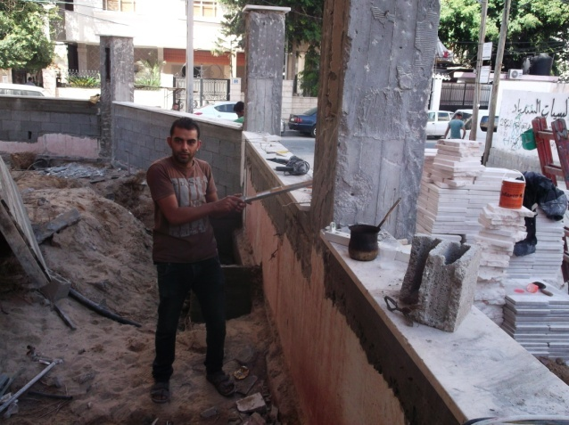**Borrower Name:** Husni Mohammad Hasan Sukar.

Mr.Sukar (before)

**Loan Number**: 000153/13/05

**Family**: 8 children

**Location: AlShaja’a, Gaza  
Loan amount: 7,000**

Mr. Sukar is a building contractor, he was granted a loan in amount of 7,000$ in 2013 for buying timber for construction. The project was located in Al-Shajaia neighborhood Alnazzaz Street, which is the same location of the borrower’s home place (a building of four levels containing the borrower’s house and his project). This location was exposed to the worst types of the Israeli aggression in the last war. On 22/07/2014, this neighborhood -without any warning- was unprecedentedly violently destroyed with all kinds of fighter jets, from aircrafts and tanks to highly explosive and destructive weapons of war.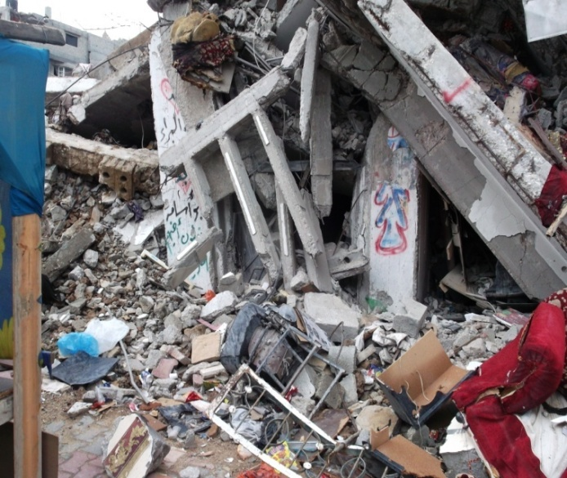 Residents fled from that district to another where they sought shelter in UNRWA schools. Unfortunately, the borrower’s house was directly targeted by the F16 aircrafts with several Israeli bombs, resulting in the destruction of the entire building. Most of the borrower’s family members succeeded in evacuating the house minutes before its destruction. Unfortunately, his eldest son couldn’t make it, After losing his house, the borrower and his family were displaced to one of the UNRWA’s schools. The borrower wanted to search for his son; he wanted to know if he was injured or martyred, but he couldn’t because the neighborhood was like a fire torch. He tried to coordinate with the Red Cross to reach his boy, but he waited several days without any response from the Israeli Occupation military forces. After 14 days, he dragged his sons’ corpse from under the house ruins, and buried his remains during a 12 hour truce. An extreme tragic scene for Mr. Sukar during this aggression was the corpse of a Palestinian with decomposed unidentified features under his home ruins.

Mr.Sukar (after)

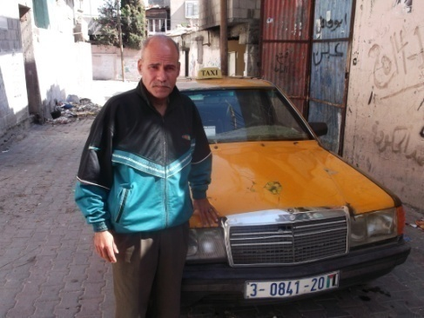**Borrower Name:** Jamal Motawe’ Ghoubon  
**Family** :8 children.  
**Loan Number:** 05/13/000124  
**Location**: Bureij Camp, Gaza  
**Loan amount:** 5,000 USD

Mr.Jamal (before)

Jamal is a taxi driver, he was granted a loan in amount of 5,000$ in 2013 to purchase a taxi. Jamal lived in Al-Bureij refugee camp in the Eastern region of the Gaza Strip. Unfortunately, his house was directly targeted by the F16 aircrafts with highly explosive missiles, in which his home was completely destroyed. Five minutes before the house was bombed, Jamal’s family was warned by missile’ drones ‘warning to vacate their home; quickly they vacated their home without taking anything (including the refinanced taxi), and fled to one of the UNRWA’s schools. The family stayed at the UNRWA school for more than one month even after the ceasefire.   
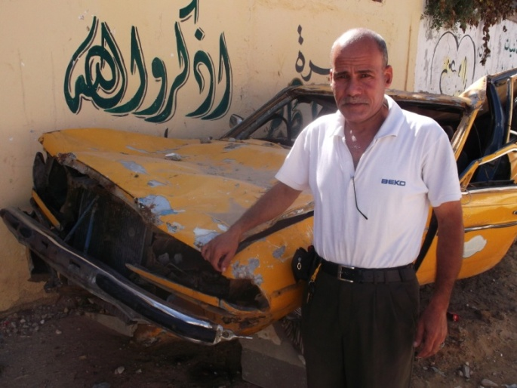

Mr. Jamal (after) with his destroyed car

### ASALA Borrowers

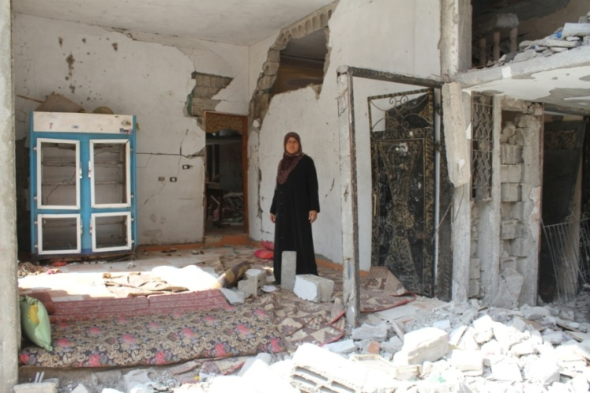**Amal M. Abu Odeh**

**Loan No:** 10/14/000153  
**Family**: 7 Children   
**Location**: Beit Hanoun, Gaza  
**Amount:** $500 USD

Amal is 47 years old. Her husband   
 construction worker, who also employs his three sons,  
  
was forced to stop working because of the lack of construction supplies since more than a year, this made Amal’s project the main source of income for the family. Amal was granted a $500 USD loan to start grocery store project under her house to generate income that can help supporting her family. During the aggression on Gaza last July, her house was directly target by F16 fighter jets and as a result was totally destroyed, it was a 3-story building. Amal’s family and her sons families were living ( a total of 20 persons) in the house, during the war they moved to UN schools, now they are living with her family.

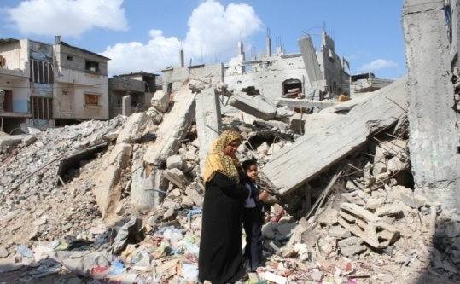**Ramzia Abu Jarad**  
**Loan No. : 10/13/000209**  
**Loan amount: $1200 USD**  
**Location :Beit Hanoun, Gaza**

Razia is 45 years old and married with 9 children. One of her daughters was married and she was killed together with her husband and his family. Ramzia was pregnant and she delivered her baby during the war. Her husband was working as taxi driver. Ramzia started grocery store project 2005 by a loan from Asala near her house, to generate income and support her big family, during the war her house was targeted and as a result was partially damaged. Her project was also targeted and totally damaged. Her husband’s car was also damaged, they moved to UN school , the air fighter targeted the UN school and her son was injured, now they are back in the house “what is left of it.”