DAMAN for SMEs
Annual Report 2020

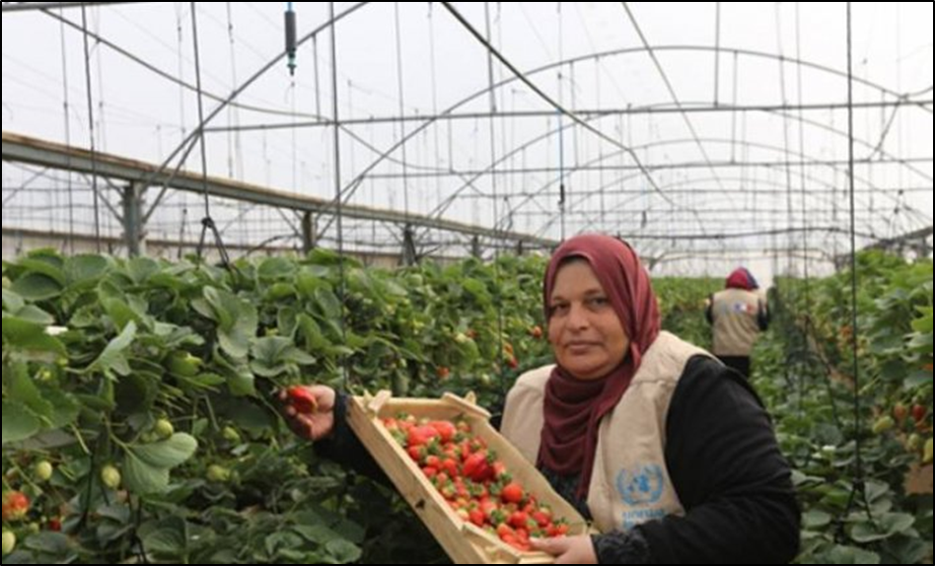

Contact information:
Address: Faramand Building, 2nd floor, Suite # 4, Al Irsal, Ramallah
Phone: +970-2-2964856
Fax: + 970-2-2964857
JAWWAL: +972-598665111 / +972-525000017
Email: Judeh.jamal@damansme.ps

Glossary

ACAD: Arab Centre for Agricultural Development
ACAD Finance: ACAD for credit and Development
ASALA: Palestinian Business women’s Association
ASALA: ASALA for credit and Development
REEF: REEF for micro finance credit
CGS: Credit Guarantee Scheme
MFI: Micro Finance Institutions
OCHA: Office for the Coordination of Humanitarian Affairs (United Nations)
OPT: Occupied Palestinian Territory
PA: Palestinian Authority
PMA: Palestinian Monetary Authority
MONE: Ministry of National Economy
SIDI: Solidarité Internationale pour le Développement et l’Investissement
EPCGF: European Palestinian Credit Guarantee Fund
MEI: Middle East Initiative for Credit Guarantee scheme
AFD : PROPARCO: Agency Française du Development
SIDA: Swedish International Development Agency
NRO: Netherland Representative office –Ramallah
SHARAKAH: Palestinian Micro Finance Network

- Preface by Mr Dominique Lesaffre

Dear stakeholders and friends of DAMAN,

Despite the sanitary context DAMAN has realized major breakthroughs in 2020.

- Agreements with the key MFIs enabling the acknowledgement by PMA of the expected covered level of provision,

- Starting of the implementation of the project funded by the Ministry of Foreign Affairs – Luxembourg and the Comité pour une Paix Juste au Proche Orient ( CPJPO ) and Solidarité Internationale pour le Développement et l’Investissement (SIDI and ACTES –France ) ,

DAMAN now represents an innovative, socially committed financial security system for the Palestinian MFIs which are undergoing a very specific risk.

I wish to warmly thank the support by all DAMAN stakeholders and operating colleagues who do not spare their involvement and commitment for the sake of secured microfinance.

With kind regards

Dominique Lesaffre
Chairman of the Board of Directors

- Introduction:

The year 2020 witnessed an extraordinary situation as the pandemic COVID19 affected all aspects of life worldwide, and in the Palestinian context the Israeli Occupation was a plus in influencing all aspects of life whether social, economic and political.

The total population in the illegally Occupied Palestinian Territories (OPT) is estimated around 4. 8 million people; 2, 9 million in the West Bank and 1, 9 million in the Gaza Strip. Amongst this total, 47% of the population (approximately 2 million people) are less than 17 years old, which means that the Palestinian society is a "youth society".

The number of households in Palestine is estimated at 919,000 where the average family size is about 5.1 persons. Amongst this figure, women head 10.6 % of Palestinian households.

During the year 2020, the closure of Gaza Strip, restriction of movement and the sanction imposed on the Palestinian Authority by stopping the tax money collected by Israel on behalf of the PA (Al-MAQASSAH) for more than 6 months in which salaries cut was imposed on the PA staff and employees, all formed a burden on the Palestinian people. Moreover, the continuance of internal division between West Bank and Gaza for the 13th year, the pandemic COVID 19, and the President declarations to impose the emergency situation during the whole year of 2020 altogether made the life of the Palestinian people more and more complicated.

The implementation of the project of DAMAN for SMEs and the partner MFIs was also affected by all the above mentioned obstacles. However, despite of all these, we managed to implement the action plan for the year 2020 in the total number of loans dispersed by the 3 MFIs which was 319 loans with a total portfolio 895.656 US$ in the West Bank, Gaza and East Jerusalem with the total amount of 244.000 Euros Credit Guarantee coverage for the 3 MFIs from DAMAN for SMEs.

- DAMAN for SMEs:

DAMAN for SMEs is a non-profit company for the Credit Guarantee Scheme registered in Ramallah under the Palestinian law on April 8th , 2015 under (562540039) aiming at enhancing entrepreneurship in the adverse context of occupation.

- Governance & Structure:

During the year 2020, a new board of members of DAMAN for SMEs was elected as reconciliation with the Not for Profit company law, the new board members are:
- Mr. Dominique Lesaffre: Representative of International Solidarity for Development and Investment (SIDI) / Chairman of the Board.
- Mr. Samir Barghouthi’ representative of ACAD Finance / vice president of the board
- Mrs. ‘Feirouz Barghothi’ representative of ASALA for Credit and Development / Treasurer

DAMAN for SMEs was established as a partnership between ACAD Finance for Credit and Development, ASALA for Credit and Development and the International Solidarity for Development and Investment (SIDI) - France and New Vision Private Consultancy company which acts as the management wing for DAMAN for SMEs. REEF Microfinance recently joined the scheme and meanwhile they are covered by the CGS of DAMAN for SMEs starting from the year 2020.

DAMAN for SMEs acts as a financial compensation instrument for vulnerable persons and groups benefiting from services of the 3 MFIs (ASALA, ACADF and REEF) in West Bank, Gaza and East Jerusalem. DAMAN for SME’s credit scheme covers the political risks that are directly affected by policies, practices imposed and implemented by the illegal Israeli occupation as well as other risks.

Vision and Mission

DAMAN for SMEs believes in the socio- economic empowerment of Palestinians as a development instrument and focuses on certain community segments which encounter high unemployment and poverty rates, such as women, new graduates, small farmers, cooperatives, and other vulnerable persons, for whom it runs out necessary to provide with business perspectives to potential entrepreneurs and thus economic and social development of vulnerable communities in Palestine.

In order to encourage investment in these areas, DAMAN for SMEs provides institutional guarantees to the MFIs, aiming at protecting them from the effects of the political related-risks on their client portfolio.

Objectives and Expected Results

DAMAN for SMEs’ objective is to contribute to sustainable access to the financial services provided by the MFIs that are directed towards vulnerable micro and small entrepreneurs in high political risk areas. In addition, DAMAN for SMEs encompasses occurrences of damages endured by borrowers because of the Israeli occupation of the Palestinian territories, expands its outreach in the West Bank, Gaza Strip and includes coverage of entrepreneurs residing in East Jerusalem. It also aims for a continuous operation of the MFIs in the Gaza Strip, East Jerusalem and area C and strengthens poverty alleviation and reduction of unemployment in the OPT.

In that perspective, DAMAN for SMEs pursues the following specific objectives:
- Enabling the MFIs to sustain their financial services to the small and micro entrepreneurs who are vulnerable to the external political shocks caused by the illegal Israeli occupation policies and measures;
- Assisting the clients of ACAD F ,REEF and ASALA in the Occupied Palestinian Territories in business management;
- Encouraging investment in areas affected highly by the occupation (small and micro income generating projects);
- Improving living conditions of the poor families;
- Creating jobs, through self-employment especially in rural and remote areas;
- Guaranteeing some of the specific risks that vulnerable clients face.
- Building the capacities of the MFIs in micro credit, social performance and other related issues.
- Working with SHARAKA and other MFIs on Advocacy and lobbying issues for MFIs

Out of these objectives, the expected results are:
- Result 1: Access of the vulnerable people to financial resources is sustained through generating funds and mobilizing resources;
- Result 2: MFIs members of DAMAN for SMEs are enabled to provide financial services to vulnerable entrepreneurs who are exposed to the Israeli illegal occupation policies and measures;
- Result 3: Supportive national policies and structures that respond to the internal policies and external political shocks are formalized through the support of DAMAN for SMEs.

- Major accomplishments during 2020:

The commencement of implementation of Luxemburg project:
During the month of November 2019, DAMAN for SMEs received a letter of approval for the project from the Luxembourg Ministry of Foreign Affairs (80%) and a co-financing from ACTES – France, CPJPO – Luxembourg (20%) and local Palestinian MFI’s in-kind contribution with a total budget of 1.050.000 Euro for 3 years 2020, 2021 and 2022.

- DAMAN for SME Guarantee Scheme:
DAMAN for SMEs managed to implement the 1st year of the project taking into consideration the huge challenges faced during this very difficult year:
- Israeli occupation continues closures and collective punishment for Palestinians by stopping the taxes collected for Palestinians by the Israelis, which obliged the Palestinian Authority to start salary cut for the staff of the public sector 50% (salary cut),
- The COVID19 pandemic which influenced all aspects of life (health, social economic and political) by lockdown of most areas of West Bank and Gaza Strip,
- The bureaucratic measures and obligations imposed on the work of DAMAN for SMEs to get approval of money transfer from international donors,
- Lack of cash and target groups mainly in high risk areas are not willing to start new business due to the critical situation (lack of cash and limited financial resources),
- The boards of the 3 MFIs starting a very careful lending process within all the above mentioned obstacles , but DAMAN for SME as a third party encourages the 3 MFIs to give more loans in high risk areas to share risk with up to 60% compensation of the outstanding balance of the defaulted loans.

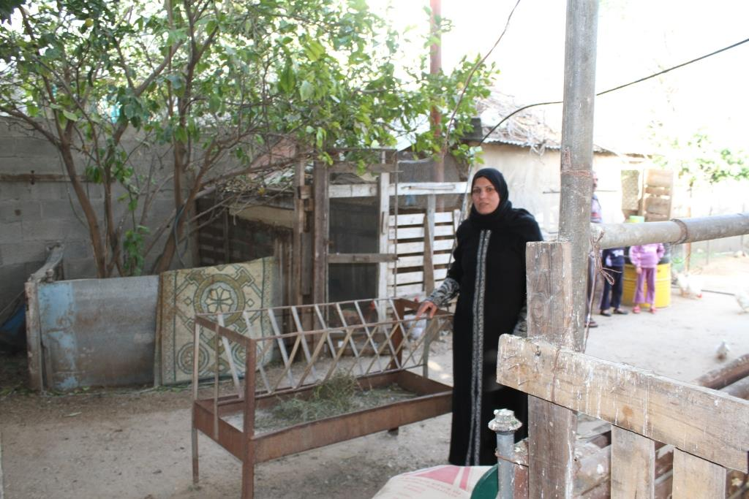

- The Program, 2020 Actual Coverage of Loans:

- DAMAN for SMEs managed to sign three MoUs with the three MFIs with a total budget of 240.000 Euro’s and give a letter of credit to each MFI, this helps the MFIs to get approval from PMA concerning the Provision for defaulted loans (PAR >180 days)
- The portfolio increment as a new revolving fund was released from provision.
- More marginalized regions and target groups have been reached.
- More profit generated, which was re-injected in the coming year loans portfolios of the three MFIs.
- In summary: 319 loans covered under the guarantees scheme of DAMAN with total portfolio 895.656 US$.
- The regions covered are Gaza strip , East Jerusalem and rural areas of the West Bank
- Women percentage in the loans given by the 3 MFIs count an average of 51.72%.
- The total loans in Gaza strip are 35 loans and 284 loans in West Bank and East Jerusalem
- The main sectors covered are:
- Agriculture 113,
- Commercial 166,
- Industrial 9,
- And services 31 loans.

Number of loans according to clusters

 | ASALA - Year 2020
Agriculture | Commercial | Industrial | Services | Total
50 | 81 | 5 | 16 | 152
 | ACAD Finance
47 | 49 | 4 | 14 | 114
 | REEF Finance
16 | 36 | 0 | 1 | 53
Total | Total | Total | Total
113 | 166 | 9 | 31 | 319

- Capacity building and training

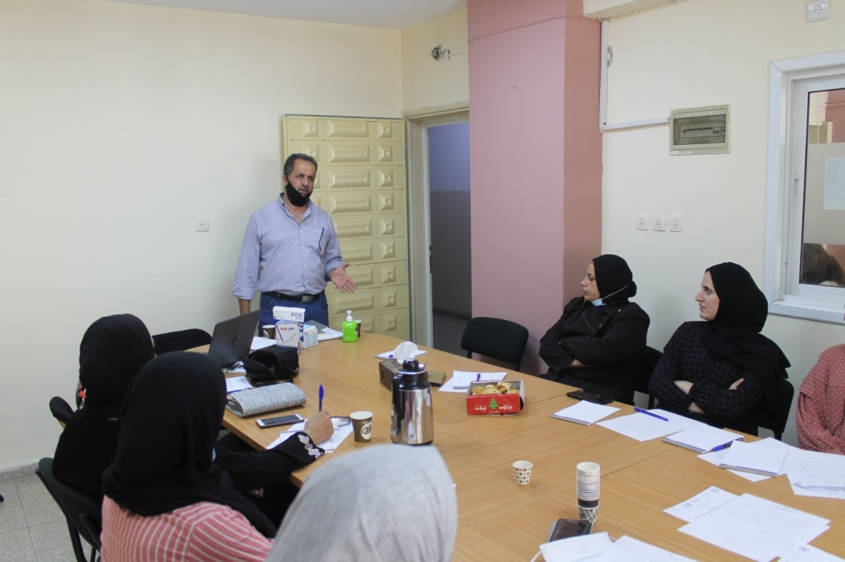

- As a result of the COVID19 restriction of movement ADA training program was cancelled this year. This training was planned to develop the capacities of the 3 MFI’s staff in risk management, financial management and human resources in close cooperation with SHARAKAH .The first step was done through a diagnostic tool developed by ADA and the MFIs did assessment of their capacity development needs, but the training was cancelled due to COVID19 .We are planning with ADA this year 2021 to implement this capacity building program in a long distance training model developed by ADA.

- DAMAN started the process of negotiation with SPTF to develop a social performance tool in close cooperation with DAMAN shareholders (ASALA, ACAD Finance and REEF) with active support from SIDI as a major shareholder of DAMAN for SMEs.

- DAMAN for SMEs contracted ACAD NGO to do 6 training courses (4 training courses in West Bank and 2 training courses in Gaza strip) 5 training was conducted in different regions (Face to Face )

And one training using on line training
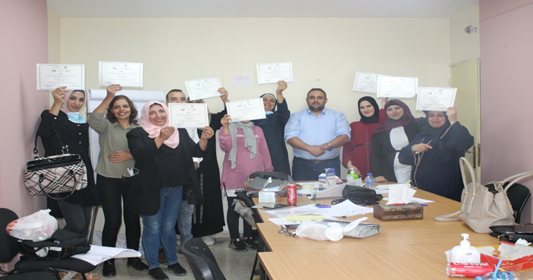

DAMAN for SMEs signed a partnership agreement with ACAD NGO to develop the capacities of DAMAN for SME shareholders’ beneficiaries (ACAD Finance, ASALA and REEF).This training program aims to develop the capacities of the beneficiaries from the 3 MFIs (Women, Youth and cooperatives), the training concentrated on financial management, feasibility study of the projects, increase the awareness of the cooperation principles in the community. A total of 90 participants benefited from these trainings in West Bank, Gaza.

The trainings were done during 3 months; part of the cost of this training was in-kind contributions as: (Training halls, trainers, refreshments and logistics from the 3 MFIs) with a total budget of 29.000 Euros.

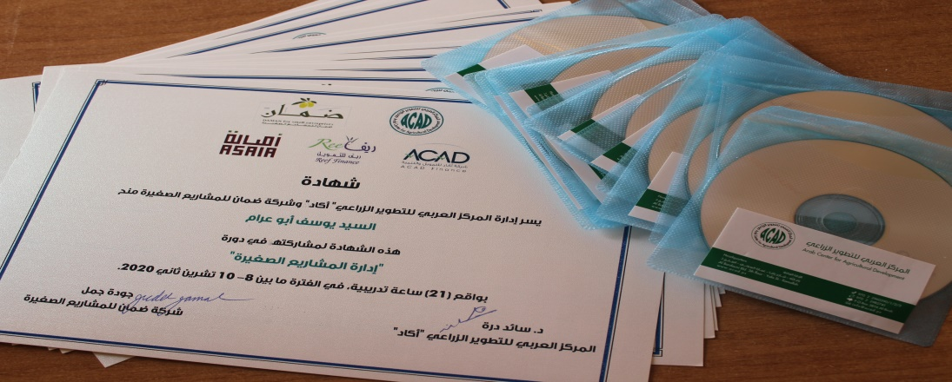

The main objective of these trainings
  - Building the human resource capacity of the beneficiaries of loans to manage their projects efficiently.
  - Decrease the risk from loans and raising the awareness of actual beneficiaries and the potential beneficiaries in future in business related matters such as business feasibility plans, book keeping, financial forecasting, marketing etc.

The other objectives
Training of the cooperative members about feasibility studies and the principles of saving and credits for their members.

Target Group
90 participants, divided into 6 groups divided in two sub groups:
- The small entrepreneur benefiting from the loans (youth, women) 3 training courses in the North and South of the West Bank and one training course in Gaza, each training course included 15 participants,
- Members of cooperatives with 3 training courses (North and South of the West Bank and one in Gaza, 3 training courses and 15 participants (men and women) in each training).

Outcome of these trainings:
- Increase number of loans with new beneficiaries
- More feasible loans and income generating projects
- More saving and credits in the cooperatives
- Reduce default loans of the MFIs

- Lobby & Advocacy:
The 3rd main objective of DAMAN for SMEs is to work closely with SHARAKAH, 9 other MFIs on the following issues:
- Laws and legislations governed the microfinance environment in Palestine (as PMA rules and regulations , Ministry of Finance and tax department )
- Donors’ awareness and raise their attention towards the importance of credit guarantee schemes as a tool for employment and create income generation projects better than the humanitarian assistance for poor and marginalized people and communities
- The development of new initiatives concerning the Credit Guarantee Schemes as a leverage of the microfinance and income generating activities.
- Training and capacity building for the microfinance institution about the last and updated techniques developed in the microfinance sector as the Social Performance Tools
- The importance of partnership, coordination and gaps filling between the main actors working in Credit Guarantee Schemes (EPCGF, MEI and AFD – PROPARCO )

  - Internal restructuring of DAMAN for SMEs:
- A new board of directors was elected
- The reconciliation of DAMAN bank account
- Appointing of the Managing Director and signing the agreement of New Vision for Management Consulting Company as a hosting for DAMAN for SMEs
- During the year of 2020 the board had 4 meetings and one ordinary general assembly and one non ordinary general assembly.
- The management team for the implementation of the project funded by the Ministry of Foreign Affairs – Luxembourg and the Comité pour une Paix Juste au Proche Orient ( CPJPO ) and Solidarité Internationale pour le Développement et l’Investissement (SIDI and ACTES –France ) consists of:
- Mr Julien Benomar from the consulting company Thesee –consulting supervisor of the project on behalf of DAMAN and CPJPO.
- Mr Christian Schmitz from France on behalf of SIDI
- Mr Judeh Jamal Managing Director of DAMAN
- The day to day management was active between the Managing Director of DAMAN and New Vision consulting company as the hosting company for DAMAN for SMEs
- The technical committee of DAMAN for SMEs held 4 meetings during the year 2020 with active participation of:
- New Vision (DAMAN hosting company)
- DAMAN for SMEs Managing Director
- Reef Finance
- ASALA
- ACAD F

  - External relations with the PA and donor community:

- Recognition of DAMAN for SMEs by the Palestinian Monetary Authority (PMA):
This achieved result was by a declaration of DAMAN for SMEs during May 2020 as one of the three Credit Guarantee schemes active in Palestine .This was a good action to help the 3 MFIs benefiting from DAMAN for SMEs to minimize the provisions of bad debt when they have defaulted loans with more than 180 days PAR, in which more revolving funds for new loans by the 3 MFIs are available.
- Reconcile DAMAN for SMEs with the Ministry of National Economy according to the Palestinian companies law which apply on the work of DAMAN for SMEs as a not for profit company .This enabled DAMAN for SMEs to get the grant for the Luxembourg project by having the approval from the Prime Minister Office during September 2020 .
- Meetings were held with AFD – PROPARCO , Consulate General of Sweden in Jerusalem SIDA , The Netherland Representative Office – Ramallah , new contacts with MEGA project (World Bank)
- Meeting EU , Middle East Initiative (MEI) and the EBRD , EBI
- Discussing with ADA, SPTF and other potential donors to apply for DAMAN phase 2 projects.

- Lessons Learned and conclusions
- The Ministry of Economy and Prime Minister office approval for the money transfer takes a massive time from DAMAN management
- The 3 MFIs are affected a lot by the COVID19 pandemic and closure of areas and governorates makes their activities too difficult, this needs a new mechanism as “mobile banking services” to be introduced.
- Regarding the training, some training planned to be done by international trainers had to be cancelled due to COVID19 effect on travel, therefore DAMAN implemented training by utilizing local trainers experience for the interest of the beneficiaries.
- Other Palestinian MFIs demanded to be covered by the project but due to the limited budget this was not possible in this phase, but this shows the relevance of the project to MFIs.
- Considering the specific context, we realize that DAMAN phase 2 is needed as a complementary step to DAMAN 1.

In conclusion we can point out, despite the following obstacles:
- Israeli occupation measures to move freely between West Bank, Gaza Strip and East Jerusalem
- Bureaucratic problems from the Palestinian Authorities
- COVID19 pandemic and obstacles caused on the general economic and health situation
DAMAN for SMEs managed to implement 90% of its action plan.
Finally, we would like to thank all shareholders and partners for their support and willingness to help DAMAN to increase the important role in aspects of economic and social sector in Palestine.

- Thanks to all Our Partners

